Project Definition: Customer Lifetime Value (LTV) Prediction System
Your project is a web-based business analytics application that predicts the future value of customers using Machine Learning and provides insights through an interactive dashboard.

Simple Definition
The Customer Lifetime Value (LTV) Prediction System is a Streamlit-based web application that uses customer purchase data and machine learning algorithms to estimate how much revenue a customer is likely to generate for a business in the future. The system helps businesses identify high-value customers, segment customers into categories, track prediction history, generate reports, and make data-driven marketing decisions.
Problem Statement
Businesses often do not know:
- Which customers are most valuable
- Which customers are likely to generate more revenue
- Where to focus marketing efforts
- How to improve customer retention
Without this information, companies may spend money on the wrong customers and lose profitable opportunities.

Proposed Solution
The system:
- Collects customer-related data (such as purchase frequency, recency, and spending).
- Uses a trained Machine Learning model to predict Customer Lifetime Value.
- Categorizes customers into segments:
  - High Value
  - Medium Value
  - Low Value
- Displays results through interactive dashboards and charts.
- Stores prediction history in a MySQL database.
- Generates reports for business analysis.
- Provides secure login and role-based access for users and administrators.

Main Objectives
- Predict future customer value accurately.
- Help businesses identify profitable customers.
- Improve marketing and retention strategies.
- Provide visual analytics and reports.
- Maintain secure user authentication and data storage.

Technologies Used
Component | Technology
Frontend/UI | Streamlit
Programming Language | Python
Machine Learning | Scikit-Learn
Data Processing | Pandas, NumPy
Visualization | Matplotlib, Seaborn
Database | MySQL
Authentication | Google OAuth
Report Generation | ReportLab
Deployment | Streamlit Cloud / Render

Key Features
User Authentication
- Google Sign-In
- User profile management
- Role-based access control
LTV Prediction
- Predict customer lifetime value
- Customer segmentation
- Real-time prediction results
Analytics Dashboard
- Revenue trends
- Customer segment distribution
- Prediction statistics
Data Management
- Store prediction history
- User activity tracking
- Login history monitoring
Reporting
- PDF report generation
- Data export functionality
Admin Panel
- User monitoring
- Login activity tracking
- System management

Expected Outcome
The application enables businesses to:
- Understand customer behavior
- Identify valuable customers
- Increase customer retention
- Optimize marketing investments
- Improve business decision-making using predictive analytics
One-Line Viva/Interview Answer
"The Customer Lifetime Value Prediction System is a machine learning-based web application that predicts the future revenue contribution of customers, segments them according to their value, and provides business insights through interactive dashboards, reports, and analytics."
Customer Lifetime Value (LTV) Prediction System
1. Problem Statement
Businesses have many customers, but not every customer brings the same value.
Some customers:
- buy often
- spend more money
- stay with the business for a long time
Others:
- buy only once
- spend less
- never return
The problem is:
“How can a business know which customers will generate the most revenue in the future?”
Without knowing this, businesses face issues like:
- spending marketing money on low-value customers
- not giving attention to loyal customers
- losing valuable customers without noticing
- poor sales planning
Example of the problem
Imagine an online clothing store with 10,000 customers.
Two customers:
Customer A
- Purchased 12 times
- Total spent ₹25,000
- Shops every month
Customer B
- Purchased 1 time
- Total spent ₹700
If the company gives both customers the same offers and marketing budget, it may waste money.
The business wants to know:
- Who is more valuable?
- Who will buy again?
- Who should receive discounts?
- Who should get VIP offers?
That is the problem.

2. Solution
The solution is the Customer Lifetime Value Prediction System.
It is a web application built using Streamlit that predicts future customer value using machine learning.
How it works
Step 1 — Collect customer data
Example:
Customer | Purchases | Total Spent | Last Purchase
A | 12 | ₹25,000 | 10 days ago
B | 1 | ₹700 | 8 months ago
C | 5 | ₹9,000 | 20 days ago

Step 2 — Machine learning analyzes patterns
The model learns from past customer behavior:
- how often customers buy
- how much they spend
- how recently they purchased
Then it predicts future spending.
Example prediction:
Customer | Predicted LTV
A | ₹40,000
B | ₹900
C | ₹15,000

Step 3 — Segment customers
Based on prediction:
- High Value → loyal customers
- Medium Value → regular customers
- Low Value → occasional customers
Example:
Customer | Category
A | High Value
C | Medium Value
B | Low Value

Step 4 — Business takes action
Then the company can decide:
For high-value customers
- VIP membership
- early access offers
- rewards
For medium-value customers
- coupons
- recommendations
For low-value customers
- re-engagement emails
- first-return discount

3. Main Motive (Most Important)
Main motive of this project:
To predict how valuable each customer will be in the future so the business can make better decisions and earn more profit.
In simple words:
The system helps answer:
- Which customers will spend more later?
- Which customers are worth keeping?
- Which customers may leave?
- Where should the business spend marketing money?

Real-life example
Suppose a business has ₹50,000 marketing budget.
Without prediction:
- Sends discounts to everyone
- Money gets wasted
With LTV prediction:
- Gives rewards to high-value customers
- Targets the right people
- Increases sales
- Saves money

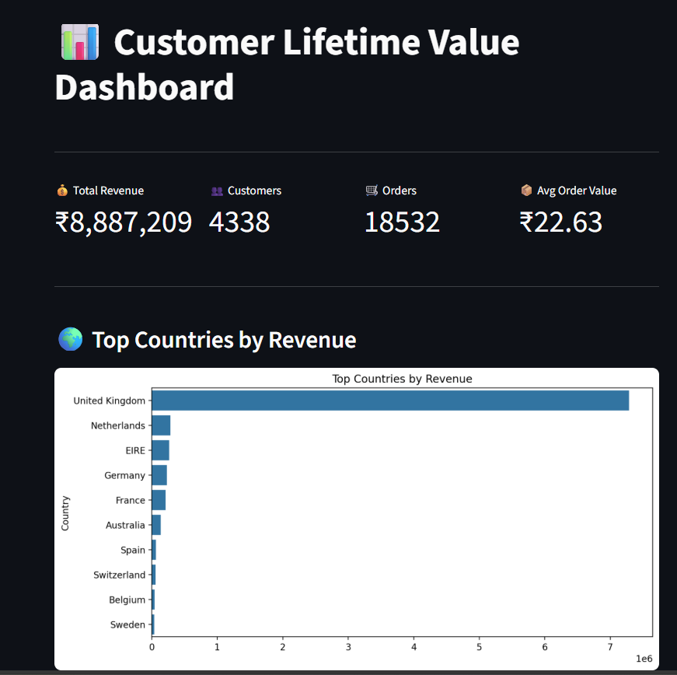

Dashboard Title — Customer Lifetime Value Dashboard
This is the main dashboard page of the Customer Lifetime Value Prediction System.
Its purpose is to display:
- customer statistics
- sales performance
- revenue insights
- country-wise business performance
It helps the business quickly understand customer value and make decisions based on data.
Customer Lifetime Value Dashboard — Explanation
This dashboard gives a quick overview of customer activity, revenue, and business performance. It helps the business monitor important customer metrics and understand where revenue is coming from.
1. Dashboard Title — Customer Lifetime Value Dashboard
This is the main dashboard page of the Customer Lifetime Value Prediction System.
Its purpose is to display:
- customer statistics
- sales performance
- revenue insights
- country-wise business performance
It helps the business quickly understand customer value and make decisions based on data.

2. KPI Summary Cards
At the top, your dashboard shows four key performance indicators.
💰 Total Revenue — ₹8,887,209
This shows the total money earned from all customers.
Meaning:
This is the sum of all customer purchases in the dataset.
Why it matters:
- measures overall business performance
- shows how much income the company generated
Example:
If:
- Customer A spent ₹10,000
- Customer B spent ₹5,000
Total revenue = ₹15,000
In your dashboard:
Total Revenue = ₹8,887,209
That means the company earned around ₹88.87 lakh from customer purchases.

3. 👥 Customers — 4338
This shows the total number of unique customers.
Meaning:
The business has data for 4,338 customers.
Why it matters:
- helps understand customer base size
- used for customer segmentation
- useful for marketing campaigns
Example:
The business can divide these customers into:
- high-value customers
- medium-value customers
- low-value customers

4. 🛒 Orders — 18,532
This shows the total number of orders placed.
Meaning:
All customers together placed 18,532 orders.
Why it matters:
- shows purchasing activity
- helps measure customer engagement
- useful for sales tracking
Example:
If one customer bought 5 times and another bought 3 times:
Total orders = 8
Your project tracks all such orders.

5. 📦 Avg Order Value — ₹22.63
This shows the average amount spent per order.
Formula:
Average Order Value = Total Revenue ÷ Total Orders
So in your project:
₹8,887,209 ÷ 18,532 ≈ ₹22.63
Meaning:
On average, each order contributes about ₹22.63 in revenue.
Why it matters:
- helps understand customer spending behavior
- useful for pricing strategy
- useful for upselling offers
Example:
If customers usually spend ₹22, the business can try to increase it to ₹30 by:
- combo offers
- recommendations
- discounts on higher-value carts

6. 🌍 Top Countries by Revenue Chart
This bar chart shows revenue generated from each country.
What it tells us
It compares countries based on total sales.
From your chart:
- United Kingdom contributes the highest revenue
- then countries like:
  - Netherlands
  - EIRE
  - Germany
  - France
  - Australia

Important insight
The United Kingdom dominates revenue compared with other countries.
Business meaning:
This means most customers or most spending comes from the UK.
So the company can:
- run more marketing campaigns in the UK
- improve delivery services there
- provide special offers for UK customers
- focus customer retention efforts there

How this connects to Customer Lifetime Value
This dashboard supports the LTV system because it helps understand:
- where the best customers are located
- how much customers spend
- how often customers purchase
- which markets generate the most value
Then the machine learning model uses this information to predict:
Future customer value
For example:
Customer from UK:
- frequent buyer
- spends more
- recent purchases
→ predicted as High LTV
Customer from another country:
- purchased once
- low spending
→ predicted as Low LTV

Simple presentation explanation
You can say this:
“This dashboard provides a visual summary of customer lifetime value data. It displays total revenue, number of customers, total orders, and average order value. It also includes a country-wise revenue chart showing which countries contribute most to sales. From the analysis, the United Kingdom generates the highest revenue. These insights help the business identify valuable customers, understand customer purchasing behavior, and support future LTV prediction using machine learning.”

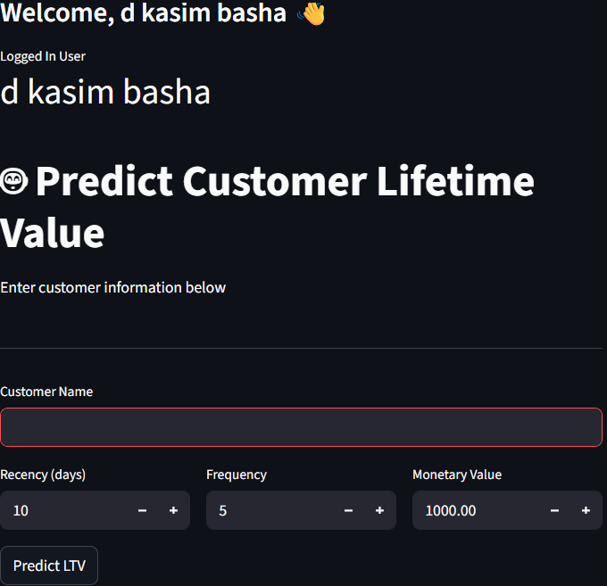

Problem the system solves
Businesses ask questions like:
- Which customers are most valuable?
- Who will buy again?
- Who may stop buying soon?
- Who should get offers or discounts?
Without prediction, they are guessing.
Example:
A store has 4,000 customers.
If it sends a ₹500 coupon to every customer:
- some customers will use it
- many won’t return
- marketing money gets wasted
The business wants to know:
“Who should we focus on?”
That’s the problem.

